Welcome to the Community First Volunteer Service – our website is www.volunteerfirst.co.uk

- If you are a new organisation you will need to register on the website before your opportunities can be added. https://www.volunteerfirst.co.uk/register-organisation/

- Once on the website select the "login/Register" button at the top of the screen. Then choose “Register your Organisation” and follow the instructions.

- If you have already registered please login as an organisation (not volunteer) You will need your email address and password which you used to register with us.
- Once you’re registered and logged in you’ll be able to add or edit opportunities and update your organisation profile as you wish.
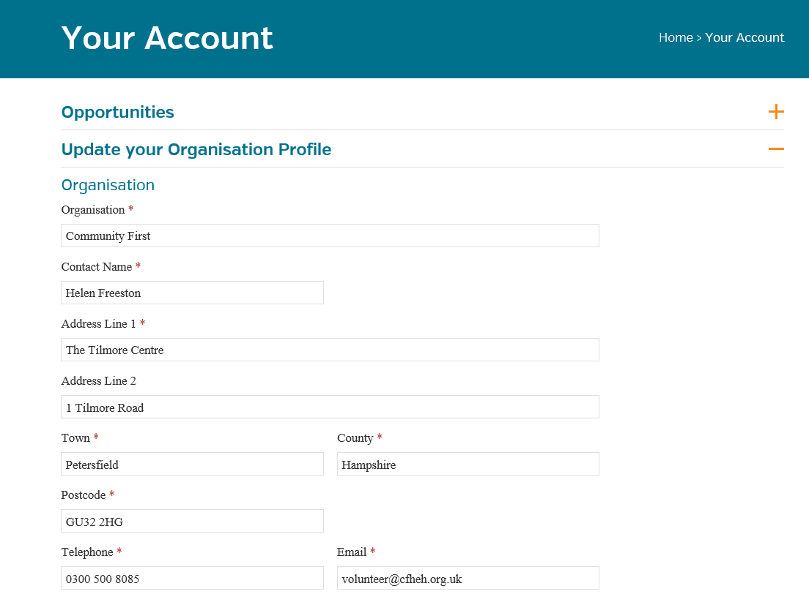

- The opportunities wont be Active until they’ve been approved by the Volunteer Service team. This is done automatically through the website, you don’t need to inform us. Please allow 2 working days for this to show on the website. We’ll set the expiry date for 6 months to a year. If specific dates are required please drop us an email.

- If you wish any of your opportunities to be made INACTIVE please email us with the opportunity title . If you wish the opportunity to be removed/deleted completley please make this clear in your email.

- The Volunteer Service team look forward to helping you find the volunteers you need. If you need any help or have any questions please email us at info@volunteerfirst.co.uk

